**The Vortex Engine and the Hydrogen Economy**

Australia has to transition quickly from fossil fuels to renewable energy. A key factor in facilitating the transition will be hydrogen. To achieve this, we have to aim for:

* The world’s cheapest renewably-generated electricity.
* Absolutely minimal negative impact on our environment, and if possible, an overall strongly positive impact.
* High reliability and availability.

**Wind and solar farms have some problems:**

**“Europe’s Electricity Generation from Wind Blown Off Course:”**

* “…Near-surface wind speed trends across the globe found that winds have generally weakened over land over the past few decades,” said Paul Williams, Professor of Atmospheric Science at the University of Reading. “This suggests that the phenomenon is part of a genuine long-term trend, rather than cyclic variability.” One explanation for this could be that “human-related climate change is warming the poles faster than the tropics in the lower atmosphere,” Williams noted. “This would have the effect of weakening the mid-latitude north-south temperature difference and consequently reducing the thermal wind at low altitudes.” Projections from the UN’s Intergovernmental Panel on Climate Change support this trend. Wind speeds over western, central and northern Europe are predicted to drop by as much as 10 per cent in the summer months by 2100, based on 1.5C warming above pre-industrial levels. Calm weather impacts UK’s wind farms. Chart showing wind powered electricity generation (rolling 14-day average, GW) Less wind has a direct impact on the amount of electricity that can be generated by the many wind farms across Europe…”

<https://www.ft.com/content/d53b5843-dbe0-4724-8adf-75c66127ea80>

Oct. 8, 2021

**Stilling: the… case of land wind speed decline**

* “…But this solution threw up more questions. After all, why would land wind speeds be going down?

Even stranger, the decline in wind speeds only appears to be happening over land, not over the oceans.

"I can't give you an explanation that will satisfy your readers as to why this is happening. I just know that it is," Professor Roderick said.

But there are a few theories.

One [theory] is that increased carbon dioxide is fuelling tree and plant growth, which is increasing surface friction and reducing surface wind speeds. Basically, there is more stuff on the surface getting in the way:

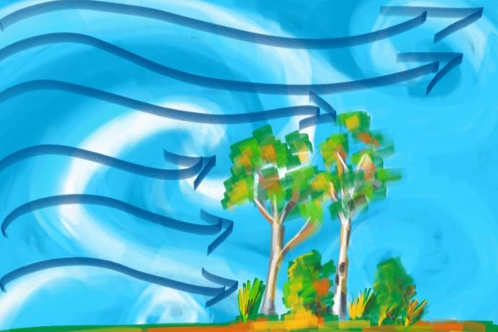

“Another of the several proposed reasons, and Professor Roderick's pet theory, is that as the climate warms, the differences in temperature between the equator and the poles will be less. Wind, after all, is just the movement of air from high to low pressure. So, if temperature and pressure is more even around the world, there will be less reason for the wind to blow…”

<https://www.abc.net.au/news/2018-10-27/land-wind-speeds-slowing-down-over-land-the-stilling/10392980>

Oct.27, 2018

* The energy available from wind is a function of the cube of its velocity, and hence a 10% reduction in velocity would impact the power output by around 27%.

“…The wind power increases with the cube of the wind speed. In other words: doubling the wind speed gives eight times the wind power. Therefore, the selection of a "windy" location is very important for a wind turbine…”

<https://home.uni-leipzig.de/energy/energy-fundamentals/15.htm>

* The Biotic Pump - how Forests Create Rain and Wind

“…When water vapor over coastal forests condenses, it lowers air pressures, creating winds that draw in moist ocean air. Cycles of transpiration and condensation can set up winds that deliver rains thousands of kilometres inland…”

Anastassia Makarieva

<https://youtu.be/kKL40aBg-7E>

**Solar PV Environmental Impacts**

“…Solar farms that cover a large amount of land are likely to have an impact on the local fauna and flora, particularly on birds. Solar farms can also inhibit local vegetation growth and damage agriculture. Unlike wind energy, solar panels aren't able to share the land they occupy for other uses…”

<https://sciencing.com/negative-effects-solar-energy-6325659.html>

**The Vortex Engine Impacts:**

The geothermal-based land area footprint of the vortex engine is of the same order as both wind or solar farms. Although the image of an updraft vortex in the form of a tornado or waterspout may seem alarming, the proposed system would be strongly controlled and anchored.

*Being relatively small, the Coriolis effect is negligible, and the vortices can be arranged to operate in either a cyclonic or anti-cyclonic sense, so that if required, the net rotational effect of a vortex engine “array” could be zero.*

Very preliminary estimates of the relative footprints, capital cost and availability of the vortex engine (AVE), photovoltaics (PV) and wind (Wind) farms for a nominal 200MW plant are:

|  |  |  |  |  |  |
| --- | --- | --- | --- | --- | --- |
|  | **Base Load**  **generation** | **Estimated** | | | |
|  | **Area (ha)** | **Cost (mil. AUD)** | **Life (yrs.)** | **Capacity factor** |
| **AVE with geothermal or solar** | Yes | 3000 | 500 | 80 | 0.95 |
| **Large scale PV** | No | 1200 | 400 | 25 | 0.25 |
| **Wind farm** | No | 2400 | 200 | 20 | 0.30 |

Although the AVE may initially seem to have a somewhat higher estimated capital cost per unit of nameplate capacity, consideration of working life (3 to 4x higher) and capacity factor (up to 4x higher) tips the scales decisively in favour of the AVE and against PV and Wind.

**WA North West Geothermal**

**Carnarvon basin**

“…High temperatures have been recognized in the Southern Carnarvon Basin (Figure 1). These elevated temperatures have been reported in various studies [12,51,56]. This region is probably the most prospective region in Western Australia for geothermal energy, behind the Vasse Shelf region in the southern Perth Basin. However, very little geothermal exploration has been carried out in the region.”

<https://www.intechopen.com/chapters/49620>

**Combating Climate Change:**

While developing nations such as those in Equatorial Africa, Indonesia and the Amazon region are still causing deforestation and burning forest debris to generate the Atmospheric Brown Cloud (ABC), replacement of fossil fuels by hydrogen will be futile, at least in the short to medium term. *Water vapour (also caused by burning of hydrogen) is by far the most important greenhouse gas, and the ABC is acting very effectively to inhibit its convection and hence precipitation from the atmosphere.*



Fig. 2

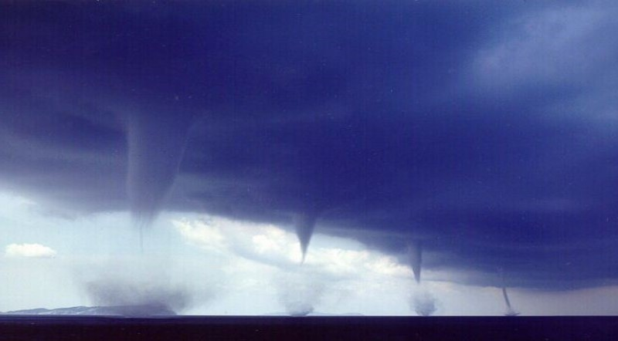

Fig. 3 An array of waterspouts off the coast of Greece.

**

Fig. 4

The Vortex Engine updraft can efficiently transfer heat on the same principle of that of the heat pipe.



Fig. 5 The buoyant vortex and convective heat transfer

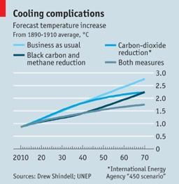

Fig. 6 The vortex engine can help to scrub black carbon from the atmosphere and produce useful power from otherwise waste gas. CO2 reduction is arguably a secondary consideration in the short to medium term.

The vortex engine can arguably be used to generate electrical power by using energy which is currently being wasted in the form of flared, or worse vented, natural gas. See <https://www.vortexengineer.com/vortex-engine-business-plan.html> .

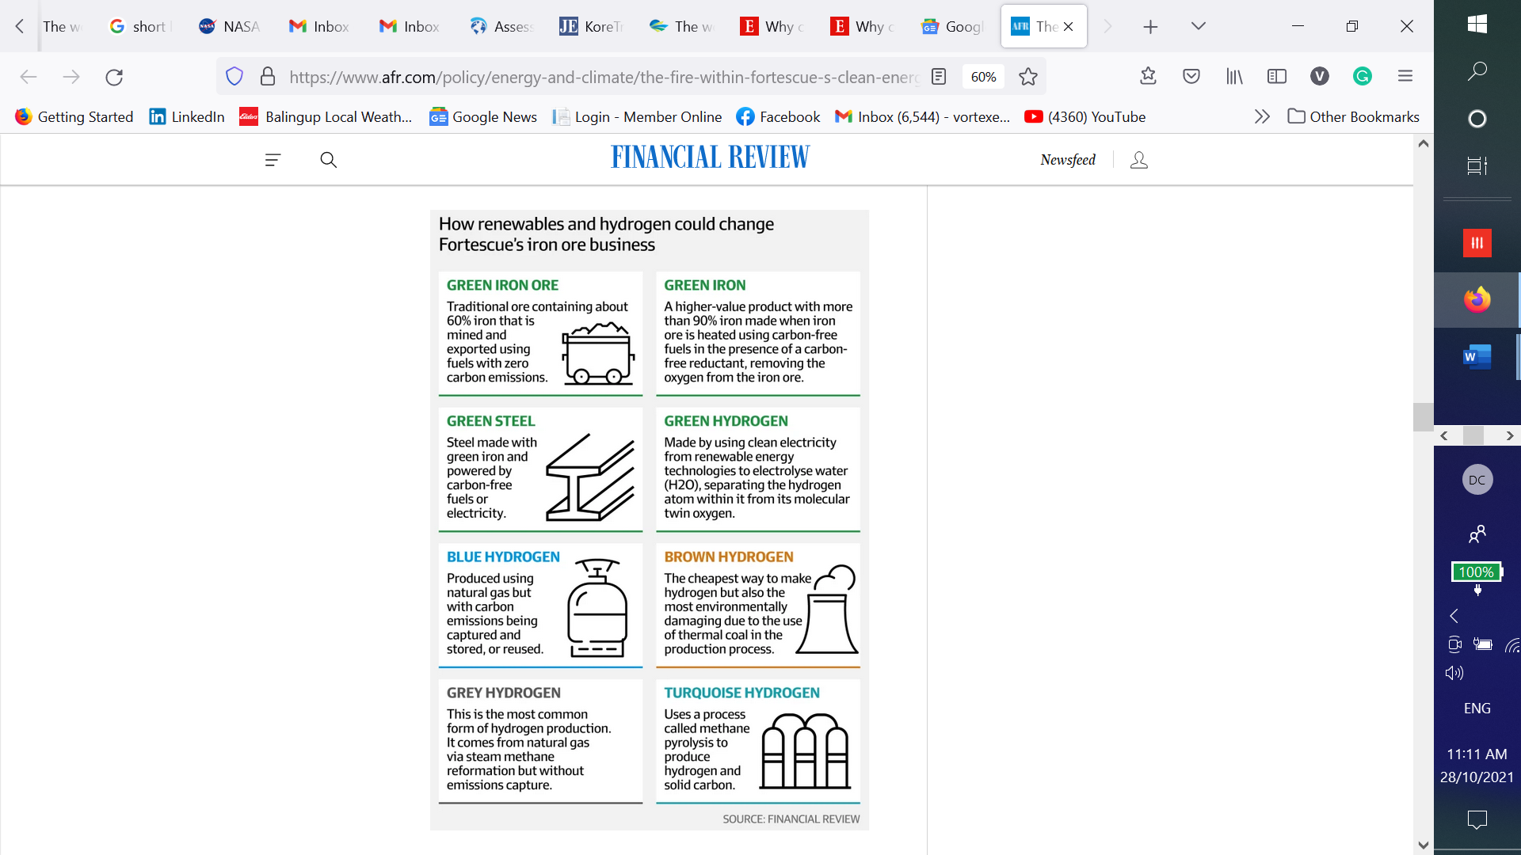

Fig. 7

**Conclusion:**

The method of generating hydrogen should arguably be:

1. Extremely low-cost. Hydrolysis and storage of hydrogen (and likely production of ammonia) involve their own inefficiencies and losses, so the cost of the process input energy must be extremely low in order to be able to compete with fossil fuels. It’s not possible to forecast the cost of energy output from the AVE until a significant amount of research has been done, but it is reasonable to expect it to be extremely competitive.
2. Having a high availability and reliability. The AVE has significant advantages over the Photovoltaic and Wind power options.
3. Not only zero carbon-emitting, but able to **scrub** black carbon from the atmosphere in order to destroy the ABC. The AVE can significantly help in achieving this.
4. Benign to the environment, increasing the share of rainfall to Earth’s land masses. Widespread Climate Change refugee migration has been forecast and is now happening due to increasing drought. Currently Earth’s land makes up 30% of its total surface area, but receives only 23% of its rainfall. The AVE can significantly help in redressing this imbalance.

In conclusion, all sources of renewable energy should be investigated, including geothermal, tidal, wave, PV and wind. It would not be wise to put all our eggs in one basket (or even two baskets.) *“…What’s necessary at this point is to do proofs of concept,” says professor* ***Kerry Emanuel****, the hurricane expert at MIT. “[The] idea is pretty simple and elegant. My own feeling is that we ought to be pouring money into all kinds of alternative energy research. There’s almost nothing to lose in trying this...”* **ODE Magazine**, March 2008